**MORTGAGES IN U.S BANKING SECTOR**

**Introduction:**

The U.S. banking sector's mortgage landscape is a cornerstone of the nation's financial system, playing a crucial role in enabling homeownership and driving economic activity. Mortgages are complex financial instruments that come in various forms, each designed to meet the diverse needs of borrowers. This overview delves into the different types of mortgages available, the key players involved in the mortgage market, the step-by-step mortgage process, and the regulatory environment governing these transactions. Additionally, it explores current market trends that influence mortgage rates, housing market conditions, technological advancements, and government policies. Understanding these elements is essential for navigating the intricacies of mortgage lending in the United States.

**Types of Mortgages:**

**Fixed-Rate Mortgages (FRMs):**

FRMs offer a stable interest rate for the entire loan term, typically 15, 20, or 30 years, ensuring predictable monthly payments. This stability appeals to borrowers seeking long-term budgeting certainty, though initial interest rates might be higher than those of ARMs. FRMs protect borrowers from market fluctuations but don't benefit from potential interest rate drops.

**Adjustable-Rate Mortgages (ARMs):**

ARMs start with a fixed interest rate for an initial period (e.g., 5, 7, or 10 years) before adjusting periodically based on market rates. This structure can offer lower initial rates, appealing to those planning to refinance or sell before adjustments. However, ARMs carry the risk of increasing payments if interest rates rise, making them less predictable than FRMs.

**FHA Loans:**

Federal Housing Administration (FHA) loans are designed for low-to-moderate-income borrowers. They offer lower down payments (as low as 3.5%) and more lenient credit requirements, making homeownership accessible to more people. FHA loans are government-insured, reducing lender risk. However, borrowers must pay mortgage insurance premiums, which can increase overall costs.

**VA Loans:**

Veterans Affairs (VA) loans provide benefits for eligible veterans, active-duty service members, and some military spouses. They often require no down payment or private mortgage insurance, offering competitive interest rates. Backed by the VA, these loans reduce lender risk. Eligibility criteria apply, and benefits include refinancing options and assistance for struggling borrowers.

**Jumbo Loans:**

Jumbo loans exceed conforming loan limits set by Fannie Mae and Freddie Mac. They finance luxury properties in high-cost areas, requiring higher credit scores, larger down payments, and stricter income verification. Jumbo loans typically have higher interest rates due to increased lender risk, and they aren't eligible for GSE purchase, limiting secondary market liquidity.

**Conforming Loans:**

Conforming loans meet Fannie Mae and Freddie Mac guidelines, making them eligible for purchase and securitization. They have lower interest rates and down payment requirements, with more flexible credit standards. These loans offer easier refinancing and are backed by GSEs, providing stability and liquidity in the mortgage market.

**Key Players:**

**Commercial Banks:**

Major mortgage providers include national banks like Wells Fargo, Bank of America, and JPMorgan Chase. They offer a range of loan products, from conventional mortgages to specialized loans like FHA and VA. These banks provide extensive customer support, but their size can sometimes lead to less personalized service compared to smaller institutions.

**Credit Unions:**

Member-owned credit unions offer competitive mortgage rates and personalized service. They prioritize members' interests, often resulting in lower fees and better customer care. Credit unions may have more flexible lending criteria, but their mortgage product range might be narrower compared to larger banks.

**Mortgage Brokers:**

Mortgage brokers act as intermediaries, connecting borrowers with various lenders to find the best mortgage terms. They offer a wide range of loan products and can save borrowers time and effort. However, brokers charge fees, and their recommendations might be influenced by lender relationships, requiring careful consideration by borrowers.

**Non-Bank Lenders:**

Non-bank lenders, like Quicken Loans and Rocket Mortgage, operate primarily online, offering streamlined and fast mortgage processes. They often have competitive rates and flexible terms, appealing to tech-savvy borrowers. However, they may lack the physical presence and personalized service of traditional banks, which can be a drawback for some borrowers.

**Government-Sponsored Enterprises (GSEs):**

Fannie Mae and Freddie Mac are crucial in the U.S. mortgage market. They purchase and securitize mortgages, providing liquidity to lenders. By setting conforming loan standards, GSEs ensure a steady flow of affordable mortgage credit. Their activities stabilize the housing market and support homeownership for millions of Americans.

**Mortgage Process:**

**Pre-Approval:**

Pre-approval involves a lender assessing a borrower's financial health to determine loan eligibility. It provides a conditional commitment for a specific loan amount, giving borrowers an idea of their budget. Pre-approval strengthens buyers' offers, showing sellers they are serious and financially capable, but it does require a credit check.

**House Hunting:**

House hunting is the process where buyers search for a property within their pre-approved budget. It involves visiting homes, assessing their condition, and evaluating neighbourhood amenities. This stage requires careful consideration of personal needs and financial constraints. A real estate agent can assist in finding suitable properties and negotiating offers.

**Loan Application:**

The loan application process involves submitting detailed financial information, including income, assets, debts, and credit history. Lenders use this data to assess the borrower's ability to repay the loan. The application includes an appraisal of the property to determine its value. This step can be time-consuming and requires accurate documentation.

**Underwriting:**

Underwriting is a thorough evaluation of the borrower's financial status and the property's value. Lenders assess the risk of issuing the loan by verifying income, employment, credit history, and appraised property value. This process ensures the borrower meets the lender's criteria and can repay the loan, ultimately determining loan approval or denial.

**Closing:**

Closing finalizes the mortgage transaction. Borrowers sign various documents, including the promissory note and mortgage agreement. They also pay closing costs, which can include origination fees, appraisal fees, and title insurance. Once completed, ownership transfers to the buyer, and the mortgage process concludes, allowing the borrower to move into their new home.

**Servicing:**

Servicing involves managing the mortgage post-closing. Lenders or third-party servicers collect monthly payments, manage escrow accounts for taxes and insurance, and handle delinquencies or modifications. Effective servicing ensures smooth payment processing and addresses borrower issues, maintaining the loan's integrity and the lender's investment.

**Market Trends:**

**Interest Rates:**

Interest rates significantly impact mortgage affordability. Set by the Federal Reserve, lower rates make borrowing cheaper, boosting home buying and refinancing. Conversely, higher rates can dampen demand. Economic conditions, inflation, and monetary policies influence rates, making them a crucial factor for borrowers and the housing market.

**Housing Market Conditions:**

Housing market conditions, driven by supply and demand dynamics, affect property prices and mortgage volumes. Factors such as economic growth, employment rates, and demographic trends influence market activity. Tight inventory can drive up prices, while an oversupply might lower them. Understanding these conditions helps buyers and lenders make informed decisions.

**Technological Advancements:**

Technological advancements streamline the mortgage process, enhancing efficiency and customer experience. Online platforms facilitate quicker applications, while big data and AI improve underwriting accuracy and risk assessment. These innovations reduce processing times and costs, offering borrowers convenient, faster, and often more competitive mortgage options.

**Government Policies:**

Government policies, including tax incentives, subsidies, and housing programs, significantly impact the mortgage market. Policies aimed at promoting homeownership, such as the Mortgage Interest Deduction, can stimulate demand. Conversely, regulations to curb speculative buying or provide affordable housing can influence market stability and accessibility, shaping overall housing trends.

**The past 5 years of data related to the U.S. mortgage market:**

**Average Mortgage Interest Rates (30-Year Fixed-Rate)**

|  |  |
| --- | --- |
| **Year** | **Average Rate (%)** |
| 2019 | 3.94 |
| 2020 | 3.11 |
| 2021 | 2.96 |
| 2022 | 5.34 |
| 2023 | 6.5 |

**Number of Mortgage Originations (Millions)**

|  |  |
| --- | --- |
| **Year** | **Originations** |
| 2019 | 7.4 |
| 2020 | 9.3 |
| 2021 | 11.0 |
| 2022 | 8.2 |
| 2023 | 7.5 |

**Total Mortgage Debt Outstanding (Trillions USD)**

|  |  |
| --- | --- |
| **Year** | **Total Debt** |
| 2019 | 15.8 |
| 2020 | 16.6 |
| 2021 | 17.6 |
| 2022 | 18.1 |
| 2023 | 18.4 |

**Median Sales Price of Existing Homes (USD)**

|  |  |
| --- | --- |
| **Year** | **Median Price** |
| 2019 | 274,500 |
| 2020 | 296,700 |
| 2021 | 348,700 |
| 2022 | 403,900 |
| 2023 | 428,700 |

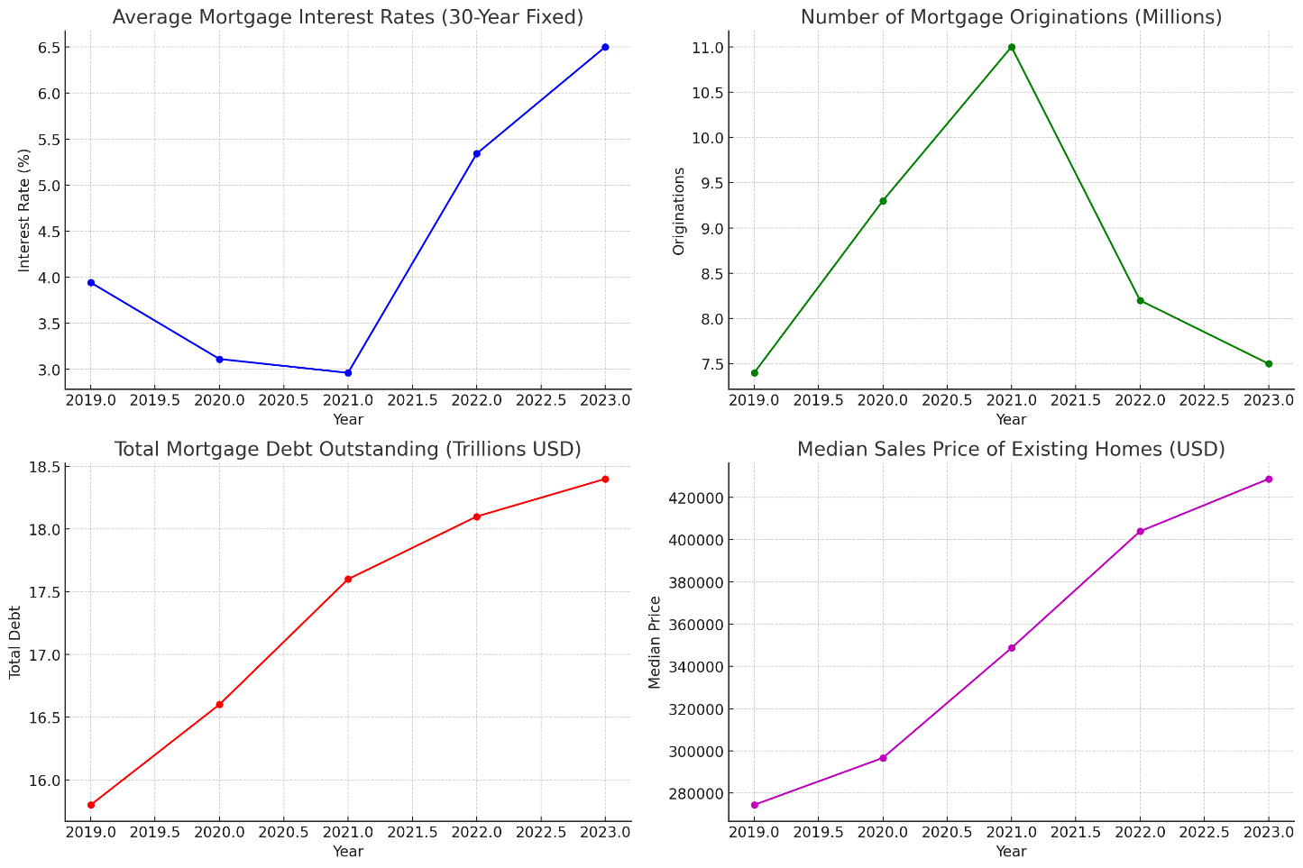

**Interpretation of Graphs**

**1. Average Mortgage Interest Rates (30-Year Fixed)**

- This graph shows a notable decline in mortgage interest rates in 2020 and 2021, reaching historical lows due to economic policies aimed at stimulating the economy during the COVID-19 pandemic. The rates sharply increased in 2022 and 2023 as the Federal Reserve raised interest rates to combat rising inflation.

**2. Number of Mortgage Originations**

- Mortgage originations peaked in 2021, driven by low interest rates and a strong housing market. The subsequent decline in 2022 and 2023 reflects the impact of rising interest rates and higher home prices, which have made borrowing more expensive and reduced the number of new loans.

**3. Total Mortgage Debt Outstanding**

- The graph shows a steady increase in total mortgage debt from 2019 to 2023. This rise is due to both the high volume of mortgage originations in the early years and increasing home prices, which contribute to higher loan amounts.

**4. Median Sales Price of Existing Homes**

- The median sales price of existing homes has consistently increased over the past five years. This trend reflects strong demand, limited housing supply, and rising construction costs, leading to higher home prices. The significant jumps in 2021 and 2022 highlight a competitive housing market with rapidly appreciating property values.

**Conclusion:**

The U.S. mortgage market over the past five years has experienced significant fluctuations influenced by economic conditions, interest rate changes, and housing market dynamics. The period saw historically low mortgage interest rates in 2020 and 2021, leading to a surge in mortgage originations and escalating home prices. However, the subsequent rise in interest rates in 2022 and 2023, aimed at controlling inflation, resulted in a slowdown in new mortgage originations and further pressure on housing affordability. Despite these challenges, the total mortgage debt outstanding has continued to grow, reflecting both increased borrowing and rising home values. Overall, the mortgage market remains a critical component of the U.S. financial system, heavily influenced by broader economic policies and housing trends.